Name : Kartik Velede

Student Number : 8672807

Assignment : Week 5 Class 1

1. Get started creating in the Power BI service

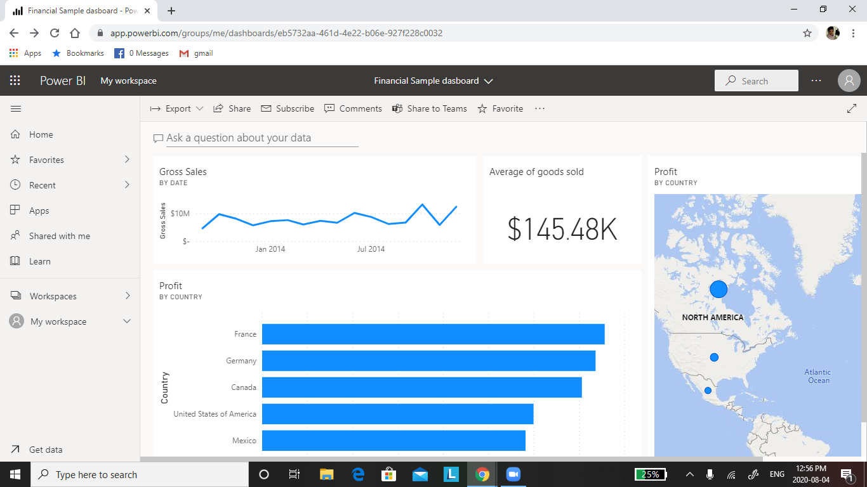

1. Edit or remove dashboard tile

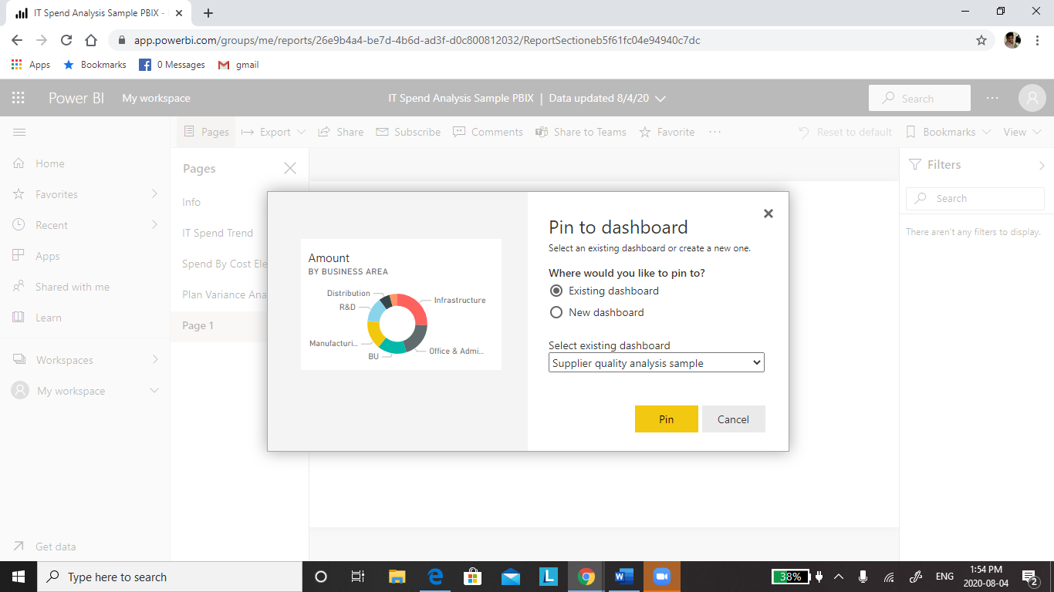

1. Adding media files

